Finance Options

Main Keywords: electrical finance, MTF finance
Secondary Keywords:
Tertiary/LSI Keywords:
Meta Title: Electrical Finance Options | MTF Finance | A1 Electrical
Meta Description: Flexible electrical finance through A1 Electrical's MTF Finance partnership. Quick approvals, transparent terms & SuperGold discounts across the Otago Region.
Breadcrumb Trail: home > finance options
Glossary of Terms: View here

IMAGE BANNER

H1: Flexible Finance Options for Your Electrical Projects

Body: Making quality electrical work accessible with flexible payment options throughout the Otago Region. A1 Electrical partners with MTF Finance to help residential and commercial clients manage electrical projects within their budget.

We understand that electrical projects represent significant investments in your property's safety and efficiency. Our finance partnership ensures you can access professional electrical services when needed, without compromising on quality or safety standards.

H2: MTF Finance Partnership

Body: A1 Electrical has established a trusted partnership with MTF Finance Dunedin South, providing competitive finance solutions for electrical projects for our clients. This partnership offers flexible terms, quick approval decisions, and transparent pricing for both residential and commercial electrical work.

Key Benefits:
- Streamlined application process with rapid approvals (most within 24 hours)
- Fixed price guarantees for complete cost certainty
- No hidden fees or surprise charges
- Flexible repayment terms to suit your budget
- Promotional offers passed directly to clients (particularly Mitsubishi heat pump savings)

H2: Why Finance Through A1 Electrical?

Body:

- ✅ Personalised help – we walk you through options and help with applications
- ✅ Local service – all finance providers operate in Dunedin
- ✅ Transparent terms – no hidden fees, clear repayment plans
- ✅ Stay compliant – all work comes with Certificates of Compliance

CTA: Connect Me With Them
Page Link: tel:+6421453193

H2: SuperGold Card Holders – Exclusive Discount

Body: If you hold a SuperGold Card, you're in luck—we offer a special discount through the government’s SuperGold scheme. It's our way of giving a nod to Dunedin’s seniors and pensioners, making essential electrical work more affordable.

H2: Mitsubishi Promotional Offers – Holiday Perks Passed to You

Body: From time to time, Mitsubishi Electric rolls out promotions that affect everything from heat pumps to smart-home gear. We pass these deals directly to you, so you’ll get premium equipment and savings together.

H2: Who This Helps

Body:
- Homeowners planning renovations, heat pumps, or new builds
- Business or commercial clients needing larger-scale electrical work
- SuperGold Card holders looking for discounted essential services
- Anyone wanting flexibility without sacrificing quality

H2: What Do I Need to Apply?

Body: To consider your application, you need to provide us with the following:
- A current New Zealand driver's licence or passport (any nationality) with proof of your NZ visa status
- A recent bank statement (less than 60 days old), in your name, showing transactions for 90 days
- A bank statement, utility or rates bill, New Zealand Government documentation or insurance confirmation showing your name and physical address
If you apply in person and bring these documents with you, we can usually give you an answer within an hour (subject to responsible lending inquiries and checks).

H3: More than you were expecting?

Body: Let MTF Finance Dunedin South help you get what you need, with affordable repayments tailored to you.

Talk to the team today.
📞 027 477 4651 – Chris Moore
✉️ dunedinsouth@mtf.co.nz
📍 481 Andersons Bay Road
🌐 mtf.co.nz/dunedinsouth
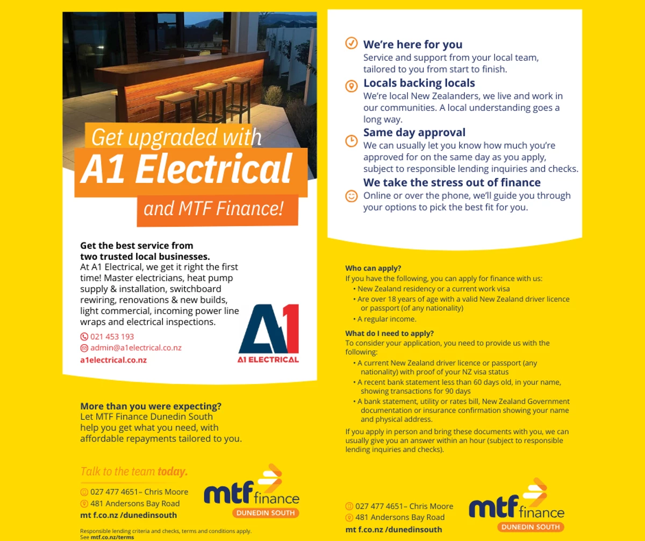

FOOTER

Body:
- Business Logo
- Address: 405 Kaikorai Valley Road, Dunedin 9011, New Zealand
- Email Address: admin@a1electrical.co.nz
- Mobile: 021 453 193
- After Hours: 03 453 0415
- Business Hours
Monday to Friday: 7:30 AM - 5:00 PM
Saturday: Closed
Sunday: Closed

Links section:
- About
- Contact
- Finance Options
- Privacy Policy
- Terms and Conditions

Certifications and Membership Logo section:
- Master Electricians
- ECANZ
- SafePower Assured
- BNI
- Super Gold

H4: Connect With Us

Body: Facebook: https://www.facebook.com/A1ElectricalContractorsLimited/

